CS 500 Project Process Summary
Personal Budgeting Application

Project Overview
For this project, I developed a command-line personal budgeting application in Python. It allows a user to enter monthly income, set a savings goal, add categorized expenses, view total spending, check savings progress, create a spending chart, and save data to a JSON file. The design focused on organization, readability, and reliable user input.

Object-Oriented Programming
I used three classes to apply object-oriented programming: Expense, BudgetCategory, and BudgetManager. Expense stores each individual amount, description, and date as an object. BudgetCategory stores a category name and a list of Expense objects, adds expenses, and calculates the category total. BudgetManager stores income, the savings goal, and a dictionary of BudgetCategory objects. This keeps related data and behavior together and makes the program easier to maintain.

Functions and Modular Design
Each method has one main purpose. set_income() and set_savings_goal() update budget values, total_expenses() calculates spending, progress_toward_goal() calculates current savings, save_data() and load_data() handle file input/output, and visualize_expenses() creates the chart. get_valid_float() and get_valid_date() are reusable validation functions. The main() function mainly displays the menu, collects input, and calls the correct method.

Coding Standards and Readability
I used descriptive snake_case names such as current_savings, savings_goal, category_name, and total_expenses, while class names use PascalCase. The code is separated into imports, classes, validation functions, and the main program. Consistent indentation and blank lines make loops and conditionals easier to follow. I also added type hints to parameters and return values to make expected data types clearer.

Libraries and Packages
The application uses json, datetime, and Matplotlib. json saves and reloads budget data in budget_data.json using UTF-8 encoding. datetime.strptime() verifies dates in YYYY-MM-DD format. Matplotlib creates a bar chart showing spending by category. These libraries provide dependable file handling, date parsing, and visualization without requiring custom versions of those features.

Secure Coding and Input Validation
get_valid_float() catches ValueError when nonnumeric input is entered and rejects negative values. get_valid_date() rejects invalid dates and incorrect formats. load_data() catches FileNotFoundError so the program starts normally when no saved file exists. The JSON file uses UTF-8 encoding for consistent text handling. The application does not execute user-supplied commands or code. Python also manages memory automatically, reducing exposure to traditional buffer-overflow problems.

Program Flow
The program creates a BudgetManager, loads saved data, and enters a repeating menu loop. Options 1 through 6 perform an action and return to the menu. Option 7 saves the data and exits. Invalid choices display an error and return to the menu. The flowchart on page 4 shows these paths, including validation, savings-goal decisions, and visualization.

Testing Methodology and Results
I performed manual unit-level and end-to-end tests in the VS Code terminal. The main test used a monthly income of $5,000, a $1,000 savings goal, and a $150 Groceries expense dated 2026-09-01. The application displayed total expenses of $150.00 and current savings of $4,850.00 and correctly reported that the savings goal was on track. After adding the Expense class, type hints, and UTF-8 encoding, I ran the program again and confirmed it still worked correctly.
Test | Expected Result | Result
Income input | $5,000.00 stored/displayed | Passed
Savings goal | $1,000.00 stored/displayed | Passed
Expense entry | $150.00 Groceries expense added | Passed
Total expenses | $150.00 displayed | Passed
Savings progress | $4,850.00 and on-track message | Passed
Visualization | Groceries bar chart displayed | Passed
Save/reload | $150.00 remained after restart | Passed
For data persistence, I selected Save & Exit, restarted the application, and selected View Total Expenses. The program still displayed $150.00, confirming that the JSON file was saved and loaded correctly. The updated load_data() method rebuilds saved entries as Expense objects. The screenshots on pages 5 and 6 document the successful tests.

Conclusion
The completed application combines object-oriented design, reusable functions, type hints, data persistence, input validation, error handling, UTF-8 file handling, and visualization. Using Expense, BudgetCategory, and BudgetManager classes strengthened the object-oriented structure. The final tests confirmed that the main requirements work correctly.

AI Use Acknowledgment
Generative AI was used for step-by-step coding guidance, debugging assistance, flowchart planning, and drafting support. I entered, reviewed, and tested the code in my development environment and verified the final program behavior.

Program Flowchart
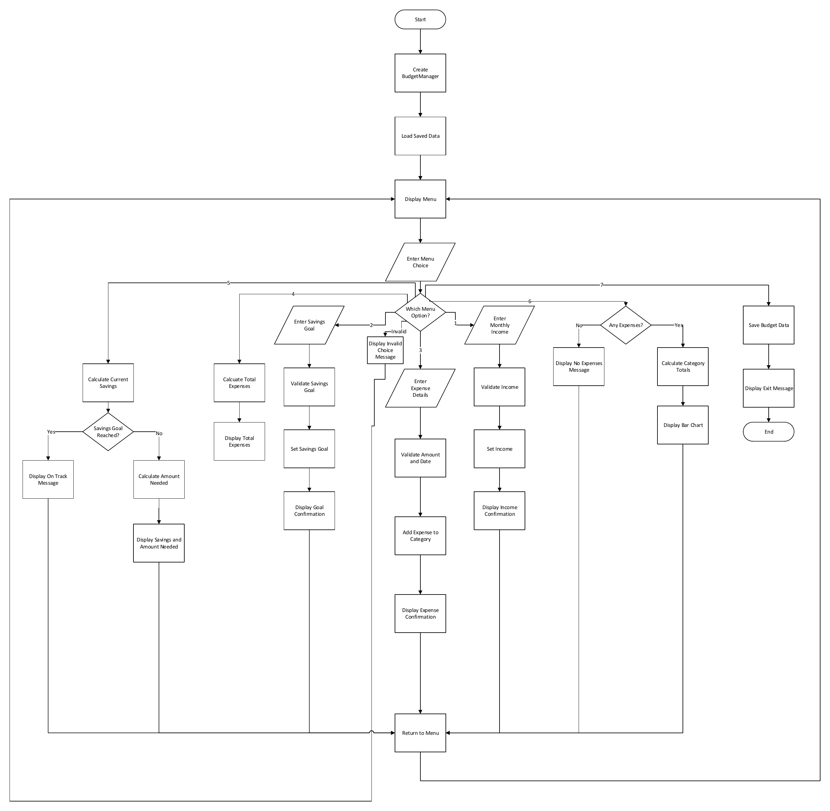
Figure 1. Personal Budgeting Application flowchart

Console Output Test Evidence
Figure 2 shows the main functional test, including income, savings goal, expense entry, total expenses, and savings progress.
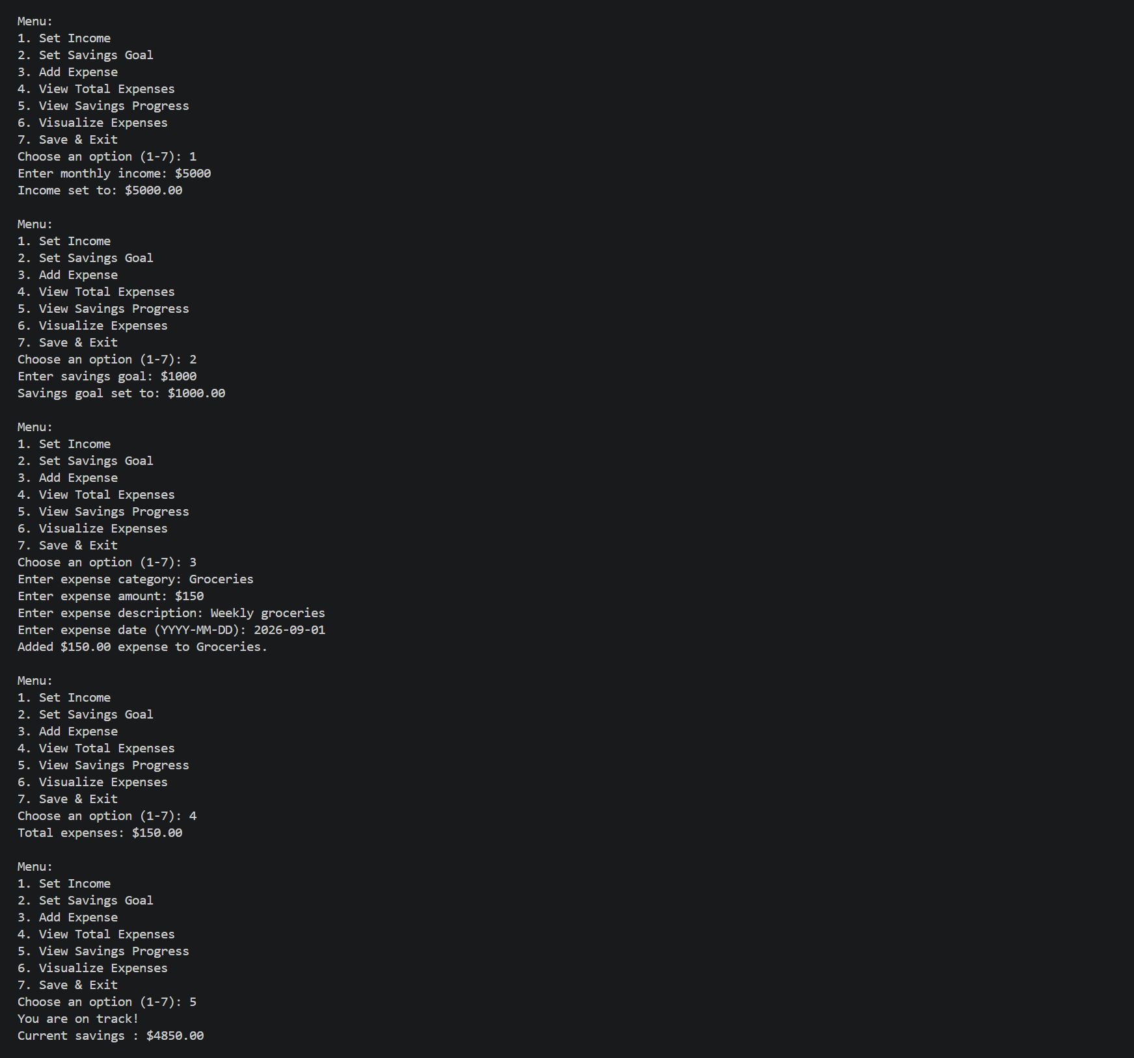
Figure 2. Main console test results

Additional Test Evidence
Figure 3 confirms that the program saved, restarted, and reloaded the $150.00 expense total. Figure 4 shows the Matplotlib bar chart.
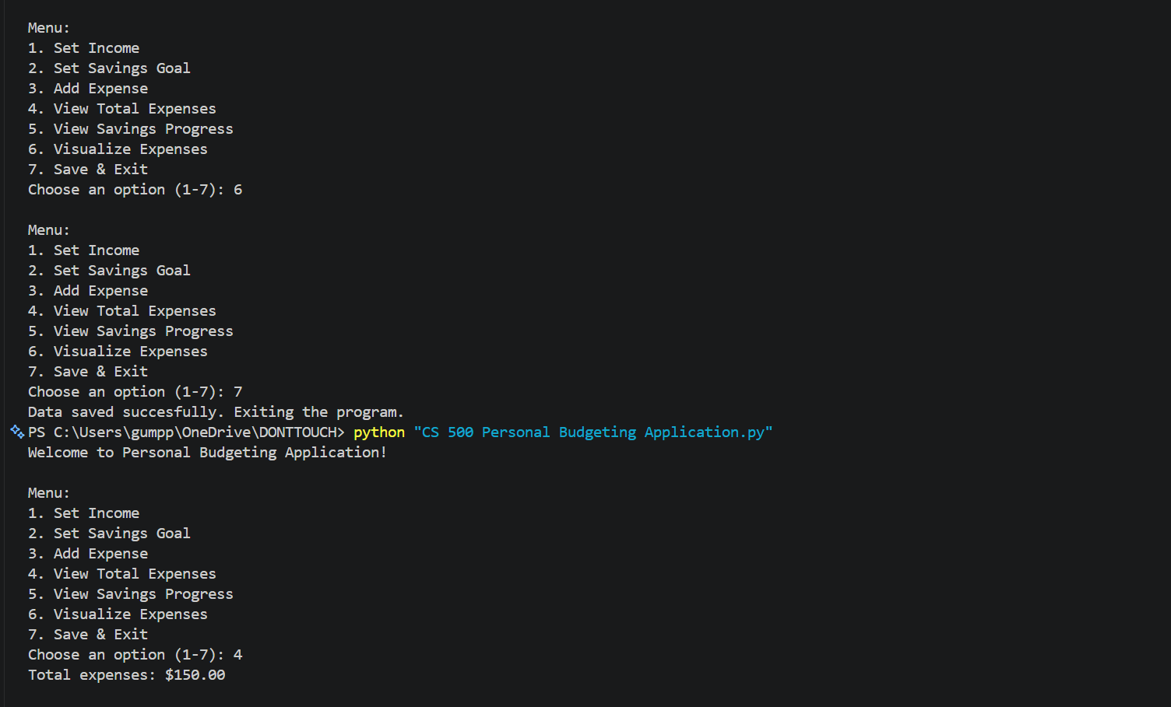
Figure 3. Save and reload test
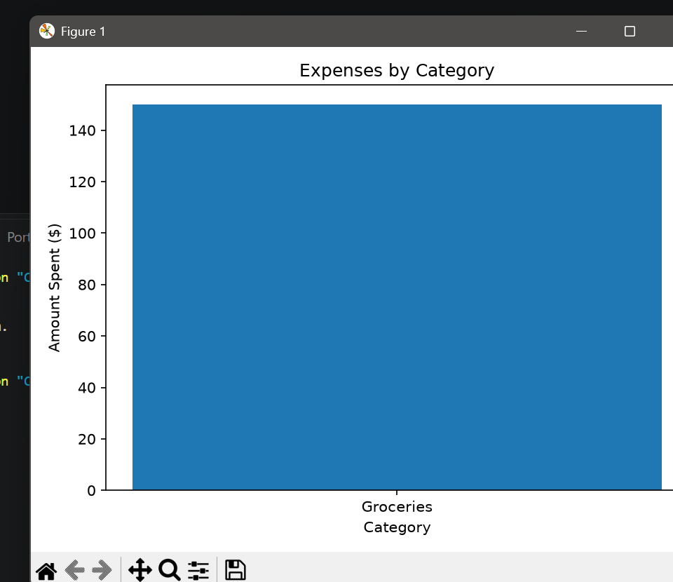
Figure 4. Expense visualization

